Exercise 7: Financial Forecasting
Recursion Concept
Recursion is a programming technique where a method calls itself to solve smaller instances of the same problem. It simplifies problems that can be divided into smaller subproblems of the same type.
Advantages of Recursion
- Makes the code simple and easy to understand.
- Useful for problems that follow repetitive patterns.
- Closely resembles mathematical formulas.
Components of Recursion
Base Case
- The condition that stops the recursion.
- Prevents infinite recursive calls.
Recursive Case
- The method calls itself with a smaller input.
- Moves the problem toward the base case.

Implementation
FinanceForcasting.java

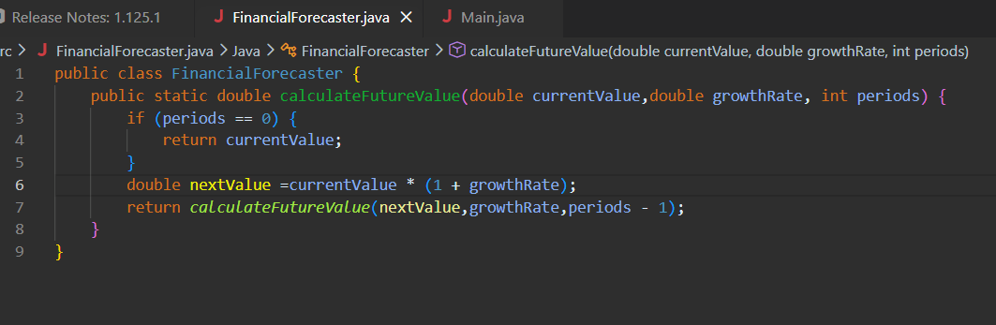

Main.java
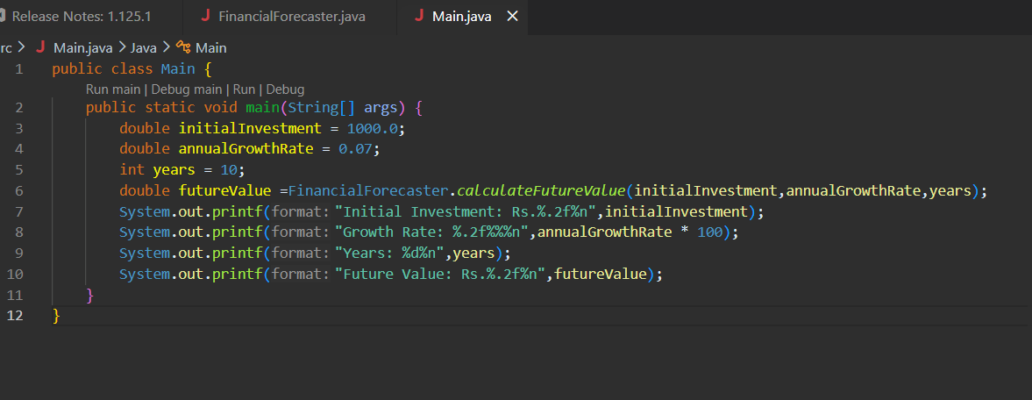

OUTPUT

Analysis
The recursive algorithm predicts future financial values by repeatedly applying the growth rate to the current value until the specified number of periods is reached.
Each recursive call calculates the value for the next period and reduces the remaining periods by one.
This approach is simple and closely follows the financial forecasting formula.

Time Complexity
Each recursive call reduces the number of periods by 1 until it reaches 0.
If there are n periods, then n recursive calls are made.
- Time Complexity: O(n)
- Space Complexity: O(n)
because each recursive call occupies space in the call stack.
Optimization Techniques
- Memoization
- Stores previously computed results.
- Avoids repeated calculations.
- Improves performance when the same values are calculated multiple times.
- Iterative Approach
- Uses loops instead of recursion.
- Reduces space complexity to O(1).
- Prevents stack overflow for large inputs.
- Mathematical Formula
- Uses the direct compound growth formula.
- Reduces both time and space complexity to O(1).
- Most efficient approach for financial forecasting.

